**ACTIVITY 1**

1. Open index.html on **Chrome**
2. Open the “**Elements**” tab of the developer’s tools (Ctrl + shift + I)

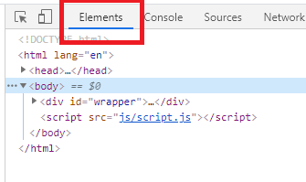

1. Answer following questions and **return your word documents on skype**:

Q1 – How many children has the element of id **add-book** ?

* 2

Q2 – What is the **parent** of the element h2 “book to read”?

* Book-list

Q3 –Why do we use id, class?

* Id: provide the specific and only one to change only element of it.
* Class: Can put many places and we can change all whenever change.
* Id and class are as name which another call to make anything, change anything on.
* Teacher’s answer, to get DOM element in the JS code by their ID or their CLASS name.

Q4 – Select the <div> of id “book-list” and delete it. What happens?

* All element in this div was deleted at all. So, we cannot see it in browser.